### **Task 1: Basic Network Scanning with Nmap**

Nmap (Network Mapper) is a powerful open-source tool used for network discovery and security auditin. Nmap scan provides an overview of active ports and their corresponding services on the target host. It is useful for network administration, security assessments, and vulnerability analysis.

1. **To install Nmap**

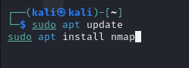

1. **Scan Initiation**

* Command Used**:**nmap bbdu.ac.in

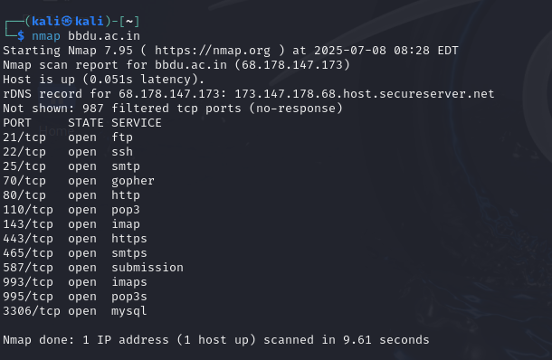

1. **Detected Open Ports and Services:**

* Port 21/tcp: FTP
* Port 22/tcp: SSH
* Port 25/tcp: SMTP
* Port 53/tcp: Gopher
* Port 80/tcp: HTTP
* Port 110/tcp: POP3
* Port 143/tcp: IMAP
* Port 443/tcp: HTTPS
* Port 587/tcp: Submission
* Port 465/tcp: SMTPS
* Port 993/tcp: IMAPS
* Port 995/tcp: POP3S
* Port 3306/tcp: MySQL



1. **Findings and Significance**

**Open Ports and Services:**

* Port 21 - FTP (File Transfer Protocol):

Significance: Used for transferring files between clients and servers. Vulnerable to various attacks if not secured.

* Port 22 - SSH (Secure Shell):

Significance: Provides secure remote access. Commonly used for managing servers. Strong security is vital.

* Port 25 - SMTP (Simple Mail Transfer Protocol):

Significance: Used for sending emails. Should be secured to prevent unauthorized use (spam).

* Port 53 - Gopher:

Significance: An obsolete protocol for sharing documents. Rarely used today, indicating potential security risks.

* Port 80 - HTTP (Hypertext Transfer Protocol):

Significance: Standard for web traffic. Unencrypted communication presents security vulnerabilities.

* Port 110 - POP3 (Post Office Protocol v3):

Significance: Used for retrieving emails. Encryption (POP3S) is recommended for security.

* Port 143 - IMAP (Internet Message Access Protocol):

Significance: Allows email retrieval with more functionality than POP3. Preferred for modern email operations.

* Port 443 - HTTPS (HTTP Secure):

Significance: Secure version of HTTP, essential for protecting sensitive data during web transactions.

* Port 587 - Submission:

Significance: Used for secure email submissions. Recommended for client to server email communication.

* Port 465 - SMTPS (Secure SMTP):

Significance: Secure version of SMTP, providing encryption to enhance email security.

* Port 993 - IMAPS:

Significance: Securely retrieves emails, using SSL/TLS for encryption.

* Port 995 - POP3S:

Significance: Securely retrieves emails using SSL/TLS, protecting user credentials during communication.

* Port 3306 - MySQL:

Significance: Default port for MySQL database access. Requires strict access controls to prevent data breaches.